Keyboard Layout for UK NE6.3-NumRow

UK NE6.3-NumRow New Orthography - no deads

This keyboard layout requires that you use a numpad or AltGr+Shift+ number row. *Diacritiqued forms (for touchscreen keyboards) are on next page.*

## Diacritic keys summary table

|  |  |  |  |  |  |  |  |  |  |  |
| --- | --- | --- | --- | --- | --- | --- | --- | --- | --- | --- |
| **Diacritics** | **ó** | **ō** | **ŏ** | **ȯ** | **o̊** | **ô** | **ò** | **ö** | **ǧ** | **g̃** |
| Dedicated key | ] | [ | # or \ | Sh + [ | Sh + ] | Sh + # or \ |  |  |  |  |
| AltGr key |  |  |  |  |  |  | AltGr + / | AltGr + b | AltGr + v | AltGr + Sh + ' |
| *Alternative key* |  |  | *AltGr + u* | *AltGr + i* | *AltGr + o* | *AltGr + m* |  |  |  |  |

## Unicode codes keyboard tables

|  |  |  |  |  |  |  |  |  |  |  |  |  |  |
| --- | --- | --- | --- | --- | --- | --- | --- | --- | --- | --- | --- | --- | --- |
| AltGr+Shift | ¬ | 1 | 2 | 3 | 4 | 5 | 6 | 7 | 8 | 9 | 0 | ≈ | | |
| AltGr | ` | ! | " or @ | £ | $ | % | ^ | & | * | ( | ) | —  U+2014 | \ |
| Shift | Ƕ | Ʃ | Ч | Ð | Þ | Ȝ | Ŋ | Ȣ | Ꝏ | Ʞ | Φ | _ | + |
| Base | ƕ | ʃ | ч | ð | þ | ȝ | ŋ | ȣ | ꝏ | ʞ | φ | - | = |
| normal | ` | 1 | 2 | 3 | 4 | 5 | 6 | 7 | 8 | 9 | 0 | - | = |

|  |  |  |  |  |  |  |  |  |  |  |  |  |  |
| --- | --- | --- | --- | --- | --- | --- | --- | --- | --- | --- | --- | --- | --- |
| AltGr+Shift | “..” | Ƕ | Œ |  | Ť |  |  |  |  |  | { | } | ~ |
| AltGr |  | ƕ | œ |  | ť |  | ŏ  U+0306  like u | ȯ  U+0307  like i | o̊  U+030a  like o |  | [ | ] | # |
| Shift | Q | W | E | R | T | Y | U | I | O | P | ȯ  U+0307 | o̊  U+030a | ô  U+0302 |
| Base | q | w | e | r | t | y | u | i | o | p | ō  U+0304 | ó  U+0301 | ŏ  U+0306 |
| normal | q | w | e | r | t | y | u | i | o | p | [ | ] | # or \ |

|  |  |  |  |  |  |  |  |  |  |  |  |
| --- | --- | --- | --- | --- | --- | --- | --- | --- | --- | --- | --- |
| AltGr+Shift | Æ | S̈ | Đ |  | G̊ | G̃ | Ǧ | Ʞ | → | : | õ  U+0303 |
| AltGr | æ | s̈ | đ |  | g̊ | g̃ | ǧ | ʞ | → | ; | ~ |
| Shift | A | S | D | F | G | H | J | K | L | Ç | @ or " |
| Base | a | s | d | f | g | h | j | k | l | ç | ' |
| normal | a | s | d | f | g | h | j | k | l | ; | @ or ' |

|  |  |  |  |  |  |  |  |  |  |  |
| --- | --- | --- | --- | --- | --- | --- | --- | --- | --- | --- |
| AltGr+Shift | Ž | Ẍ | Ç |  |  | И |  | ↑ | ↓ | ¿ |
| AltGr | ž | ẍ | ç | ǒ  U+030c | ö  U+0308 | и | ô  U+0302 | ← | → | ò  U+0300 |
| Shift | Z | X | C | V | B | N | M | < | > | ? |
| Base | z | x | c | v | b | n | m | , | . | / |
| normal | z | x | c | v | b | n | m | , | . | / |

When creating the layout, remember to check the .KLC file afterwards, manually.

* Are all shift states correct? Must match up for Caps Lock too.
* Is the layout naming correct? MSKLC doesn’t do it correctly.

## Keyboard layout images

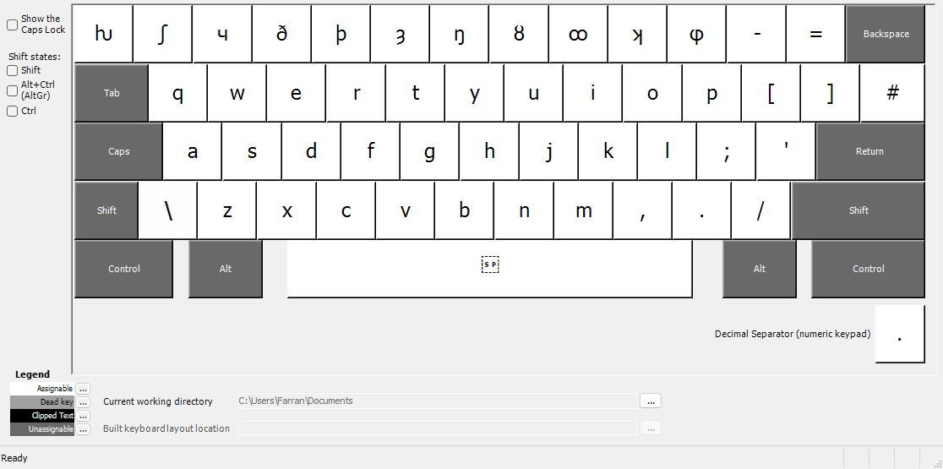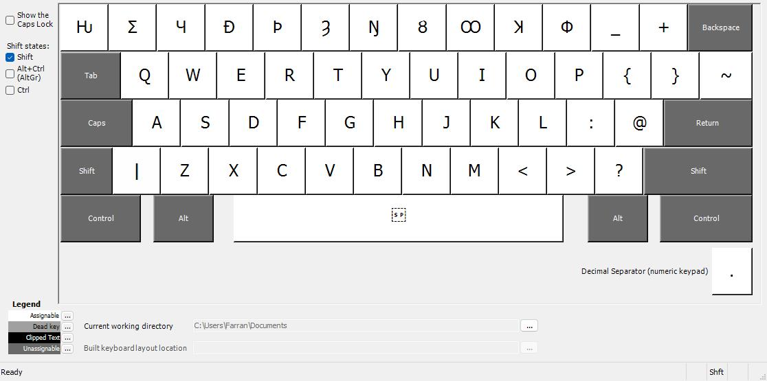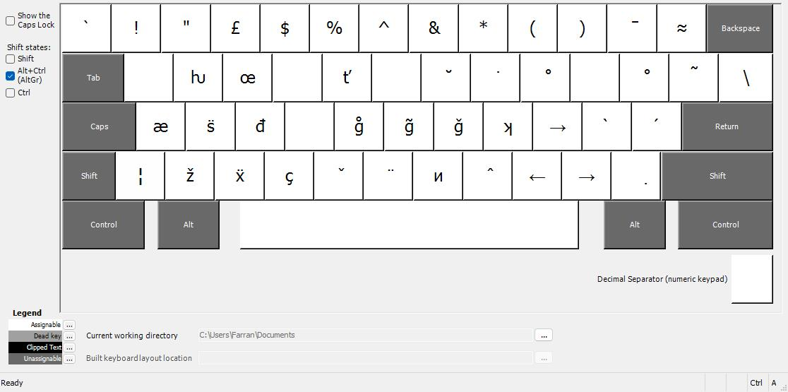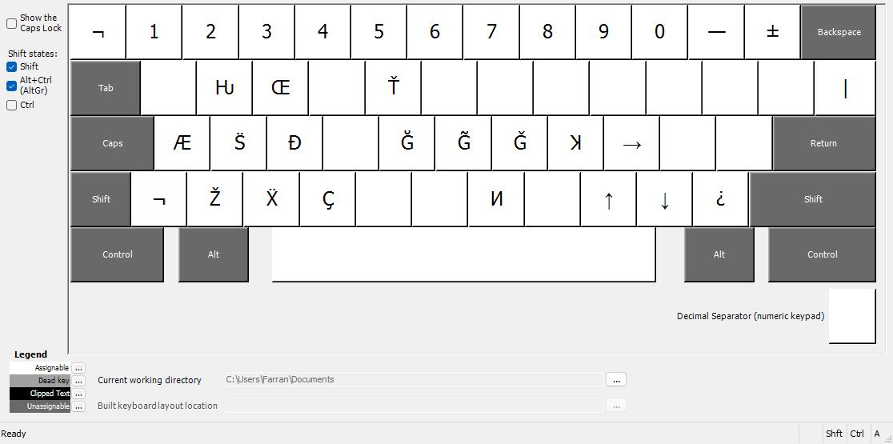

**NOT YET UPDATED FOR NE6v3**

¡ ‽ 3ɛ€ʔδʊ!”!”!ɜː₫%%%Δ⟨⟩—≈|}{€¥£

## Diacritiqued forms (for touchscreen keyboards):

**NOT YET UPDATED FOR NE6v3**

Diacritics are combined with base letters.

Pre-composed glyphs are shown in orange. Undecided on which should be used. It seems that pre-composed glyphs take up two character blocks anyway, so using them doesn’t save char space.

Glyphs included in keyboard layout are shown in green.

|  |  |  |  |  |  |  |  |  |  |  |  |  |  |
| --- | --- | --- | --- | --- | --- | --- | --- | --- | --- | --- | --- | --- | --- |
| normal | ` | 1 | 2 | 3 | 4 | 5 | 6 | 7 | 8 | 9 | 0 | - | = |
| AltGr+Shift | ¬ | 1 | 2 | 3 | 4 | 5 | 6 | 7 | 8 | 9 | 0 | — | ± |
| AltGr | ` | ! | " | £ | $ | % | ^ | & | * | ( | ) | ō | ≈ |
| Shift | Ƕ | Ʃ | Ч̌ | Ð̈ | Þ̈ | Ȝ̌ Ȝ̊ | Ŋ | Ȣ̈ Ȣ̂ Ȣ̄ Ȣ̊ AŬ AW | Ꝏ̂ Ꝏ̊ Ꝏ̆ | Ʞ̌ | Φ | _ | + |
| Base | ƕ | ʃ | ч̌ | ð̈ | þ̈ | ȝ̌ ȝ̊ | ŋ | ȣ̈ ȣ̂ ȣ̄ ȣ̊ aŭ aw | ꝏ̂ ꝏ̊ ꝏ̆ | ʞ̌ | φ | - | = |

|  |  |  |  |  |  |  |  |  |  |  |  |  |  |
| --- | --- | --- | --- | --- | --- | --- | --- | --- | --- | --- | --- | --- | --- |
| AltGr+Shift | “..” | Ƕ | Œ |  | Ť |  |  |  |  |  |  |  | | |
| AltGr |  | ƕ | œ |  | ť |  | ŏ | ȯ | o̊ |  | o̊ | õ | \ |
| Shift | Q̌ | W̄ | É Ē Ė E̊ Ĕ Ê Ë | R | T̈ Ť | Ẏ Ÿ  Ẏ Ÿ | Ú Ū U̇ Ŭ Û Ü | Í Ī Ï | Ó Ō Ȯ O̊ Ŏ Œ Œ̇ Ô Ö O̊̂ | P | { | } | ~ |
| Base | q̌ | w̄ | é ē ė e̊ ĕ ê ë | r | ẗ ť | ẏ ÿ  ẏ ÿ | ú ū u̇ ŭ û ü | í ī ï | ó ō ȯ o̊ ŏ  œ œ́ œ̇ ô ö o̊̂ | p | [ | ] | # |

|  |  |  |  |  |  |  |  |  |  |  |  |
| --- | --- | --- | --- | --- | --- | --- | --- | --- | --- | --- | --- |
| AltGr+Shift | Æ | S̈ | Đ |  | G̊ | G̃ | Ǧ | Ʞ Ʞ̌ | → |  |  |
| AltGr | æ | s̈ | đ |  | g̊ | g̃ | ǧ | ʞ ʞ̌ | → | ò | ó |
| Shift | Ā̆̇ Á Ā Ȧ Å Ă Æ Æ̇ Â | S̈ Š S̈̌ | D̈ Ď | F̈ | G | H | J̌ | K | L | : | @ |
| Base | ā̆̇ á ā ȧ å ă æ æ̇ â | s̈ š s̈̌ | d̈ ď | f̈ | g | h | ǰ | k | l | ; | ' |

|  |  |  |  |  |  |  |  |  |  |  |
| --- | --- | --- | --- | --- | --- | --- | --- | --- | --- | --- |
| AltGr+Shift |  | Ẍ | Ç̌ |  |  | И |  | ↑ | ↓ | ¿ |
| AltGr |  | ẍ | ç̌ | ǒ | ö | и | ô | ← | → | ọ |
| Shift | Z Ž | Ẍ X̌ Ẍ̌ | Č C̃ C̊ Ç Ç̌ | V̈ | B | N | M | < | > | ? |
| Base | z ž | ẍ x̌ ẍ̌ | č c̃ c̊ ç ç̌ | v̈ | b | n | m | , | . | / |

Diacritics row for touchscreen keyboard

|  |  |  |  |  |  |  |  |  |  |  |  |
| --- | --- | --- | --- | --- | --- | --- | --- | --- | --- | --- | --- |
| Diacritic | ō | ȯ | o̊ | ŏ | ô | ǒ | ö | ö̌ | ó | ò | õ |

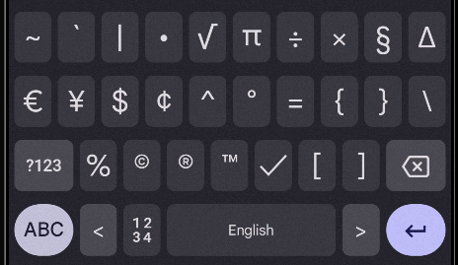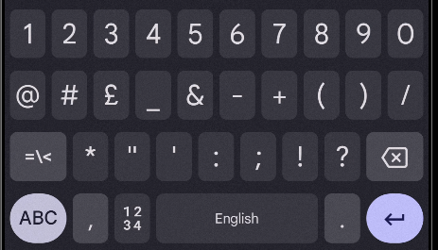 Symbols copied from GBoard